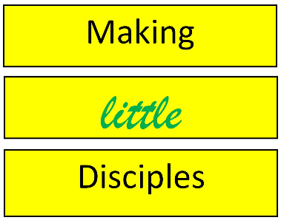

3B Philosophy Powered by Awana
Resilient Child Discipleship is designed to form lasting faith by helping kids _________ to God and His Kingdom, __________ in Jesus Christ as Lord and Savior, and to __________ like Jesus and walk in His ways through the power of the Holy Spirit.

Child Discipleship is Counter-Formation.
The ___________ ___________ may very well be forming our kids, but child discipleship is a powerful type of counter-formation that _________ _______ against the myriad of influential forces that form our children.

But instead of pushing back in anger, divisiveness, and hate, child discipleship _________ __________ with irresistible love, relationship, belonging, truthfulness, kindness, reality, faithfulness, redemption, restoration, and beyond.

“Child discipleship is the fearless future of the church.
I can’t think of a better way to invest your life than this.”
Matt Markins – Awana President and CEO

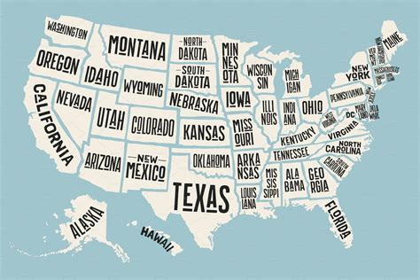
Are we
now living in a
Post-Christian culture?

Secularism is now the ________________ culture that is _____________ and _____________ our kids.

What are the Key Factors that Form Identity?

- ____________________
- ____________________
- ____________________

How do we want them to find these things?

Engaging kids in the __________ is the primary way for them to ___________ and _____________ Jesus for a lifetime.

Let's explore how we can practically implement these in our club using the 3B Philosophy.

Belong - Highly _________________ ministry
led by loving caring adults.

One loving, caring adult can make all the difference in the _______________ _________________ of a child.

What is the difference between Fitting in versus Belonging?

Fitting in is about assessing a situation and becoming who you need to be in order to be accepted.

Belonging, on the other hand, doesn’t require us to change who we are; it requires us to be who we are

Belonging ministries are places where: Kids are ______________________
Kids are ______________________
Kids are ______________________

The world has produced two ways to involve our children:



____________________________ __________________________
____________________________ __________________________
____________________________ __________________________
____________________________ __________________________
Today’s kids are starving for real, ______________, relational engagement that ___________ them to a place where they can say,
“I have found my _________________.”

Why is the sense of belonging so important?
Because we have seen the effects when it does not happen.
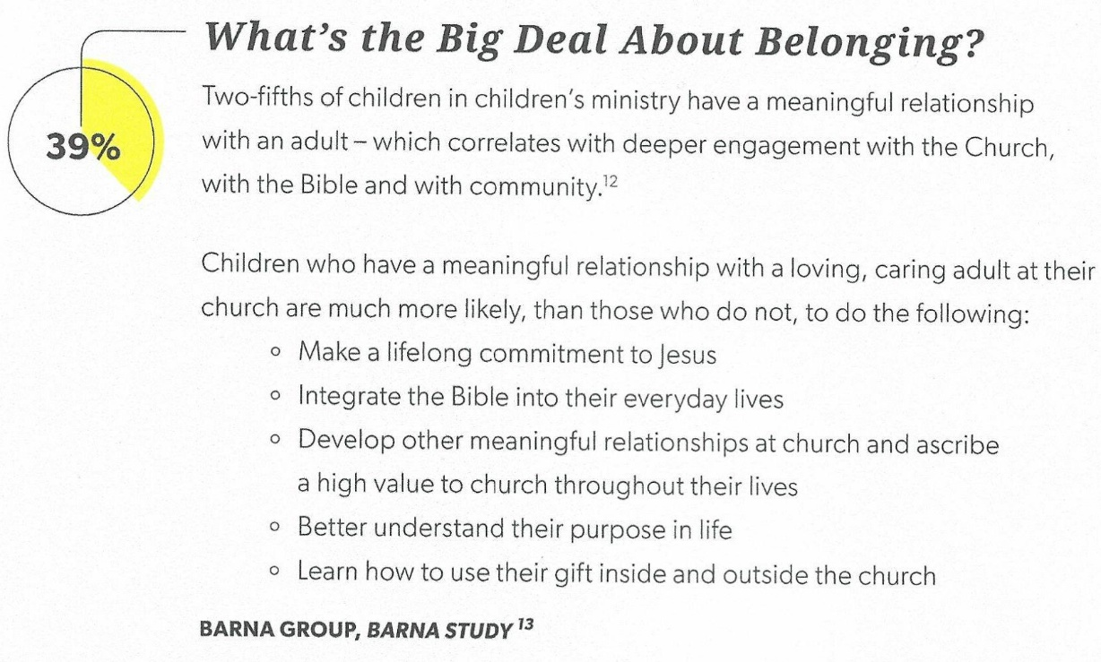
What are the 4 “Belonging” Practices of a Child Disciplemaker?
- Child Disciplemakers make sure every child feels ___________ and ____________ and has a sense of ____________________.
- Child Disciplemakers know that just __________ moment ________________ in a child can make a _______________________ impact.
3. Child Disciplemakers ____________________ each child’s ________________ needs, _____________________, environment and context.
4. Child Disciplemakers _______________ each child has their own _________________ relational discipleship formation ______________________.

The Disciplemakers Goal:
That every child would sense God’s love for them and long to love Him in return.
_________________________________________________________________________________
Believe - Deeply _________________ ministry rooted in the _______________ and the ___________ of God’s word in order that kids may know, love and serve Jesus Christ.

The Bible is our _______________. It ____________, guides, and _____________.
It informs _______________________ that we do.


Jesus did many other miraculous signs in the presence of His disciples, which are not recorded in this book. But these are written that you may believe that Jesus is the Christ, the Son of God, and that by believing you may have life in His name. (John 20:30-31)

Resilient Insight: Engaging kids in the Bible is the _________________ way for them to _____________ and follow Jesus for a _________________.

What we know about Scripture:
The Bible is a _________________, _________________ document that creates a ______________________ for understanding _________________. (2 Tim. 3:15)
The Bible gives kids access to a ______________-_________________ worldview.
(1 John 5:13)

What are the 4 “Believing” Practices of a Child Disciplemaker?
- Child Disciplemakers show how the Bible _____________ them understand reality.
A Biblical Worldview that is consistent with reality…
_________________: God created people in His image.
_________________: People chose to go their own way and a separation occurred as a result.
___________________: God fulfilled His promise to send a Savior, Jesus Christ.
___________________: We are made right and given a right relationship with God by salvation through Jesus.

- Child Disciplemakers help kids experience the Bible in ____________________ as they develop.
Make the Bible accessible to kids through _______________ and by ________________.
______________to the Bible being read ____________ each week.
Engage in _______________ reading of Scripture. (Isa. 55:10-11)


Questions to Ask:
1. What did you picture in your mind as you read that?
2. What is your favorite part of that story and why?
3. What would you have done if you were there?
4. Is anyone in the story like you?
5. What did we learn?
6. What can we take away from the story?

HE – WE – ME Questions
HE – Questions about ____________
What did I learn about God in this passage?
WE – Questions about ____________
How does this affect others?
ME – Questions about ____________.
What does God want me to know about Him?

- Disciplemakers help kids _______________ Scripture so they can ______________ the Bible __________________________.
Help them start their own practices.
Study the Bible on their own. Memorize other Scripture. Pray the Scripture. Create spaces to think and meditate on the Bible.
- Disciplemakers lead kids to _______________ in Jesus.
Not just faith for Salvation but lifelong faith in trusting Him for _____________________ in life.
All men are like grass, and all their glory is like the flowers of the field; the grass withers and the flowers fall, but the Word of the Lord stands forever.
(1 Peter 1:24-25)

The Disciplemaker’s Goal:
That every child would Trust and Abide in Jesus

Become - Truly experiential ministry designed to help kids navigate a changing culture, experience God’s presence, and walk in the ways of Jesus.

“Faith is forged in the real experiences of Life.”
Let us consider the story of Jesus and Zacchaeus from Luke 19:1-10
Jesus showed Zacchaeus that he _______________. As a result of his time spent with Jesus, Zacchaeus _______________ Jesus was who He said He was. And then Zacchaeus made a big change to ___________________ a follower of Jesus, pledging to give back four times what he owed. (Luke 19:1-10)

We often ask kids, “What do you want to be when you grow up”?
We should be asking what do you want to ____________________?

Therefore, if anyone is in Christ, he is a new creation; old things have passed away; behold, all things have become new. (2 Cor. 5:17)

4 Becoming Practices of a Child Disciplemaker
1. Child Disciplemakers _________________ and _____________ engage kids in conversation.
Give kids an ___________________ to talk. Give kids a problem to _______________.

2. Child Disciplemakers share their personal ____________ _____________ with the children.
Can give them a real ___________ to follow. Share your _________________ salvation story.
Tell them about a time when God showed up during a ________________ season in your life.
Talk about a time when you ___________________ up and needed forgiveness.
Tell about when you ______________________ God at work around you.

- Child Disciplemakers Model and invite children to ________________________ God and _____________________________ in the ways and practices of Jesus.
Help them see how others model the Spiritual disciplines:
Prayer, worship, Bible Study, journaling, silence, service, confession,
celebration, hospitality and generosity.

4. Child Disciplemakers give kids __________________ to use their gifts to __________ others.
Allow the church to be a place where gifts and talents are ___________________, practiced, and _______________________.

The Disciplemaker’s Goal:
That every child would live like Jesus lived.

Can Awana work to make strong disciples for Christ? Our track record is clear.

_________ of Awana Alumni continue to go to church as Adults.
_________ of our Alumni say that they wholeheartedly believe in God.
_________ believe the Bible is God’s Word.

“If we want to disciple children, we must encounter them wholeheartedly with vulnerability and honesty in the spaces where they live and play. In this way, we can help children recognize and respond to God wherever they are.” Barna Group


What happens when only two of the “B’s” are present?
Beli Believe + Become – ________________ = a faith that is _____________________ from the community of the church.rom
Become + Belong – ___________ = a faith not ____________ in the Scripture.
c Belong + Believe – _____________ = a faith with no _________________.

You need all of the 3B’s (Belong, Believe, and Become) to shape a child’s identity in Christ and build a resilient faith that can hold up in a culture that stands in opposition.
So what do we do with the information that we

learned about the 3 B’s?

3 responses: Do nothing new
Implement something new
Stop doing something that is not helping make Resilient Disciples

Remember the definition we started with today.

Resilient Child Discipleship is designed to form lasting faith by helping kids belong to God and his Kingdom, believe in Jesus Christ as Lord and Savior and to become like Jesus and walk in His ways through the power of the Holy Spirit.

Hopeful Takeaways from today:
Two-thirds of kids in children’s ministry have a meaningful relationship with a caring adult.
Help kids have a deeper engagement with the church, with the Bible, and the community.

Challenge to all of us as we continue to minister to the children and families in Awana.
Can you be that leader in a child’s life this year in club?

The Goal for all the leaders in Awana:
Belong: Lead children relationally with great care, concern, and love so they will love and follow Jesus.
Believe: Model and prioritize the truth of God’s Word and the power of the Gospel as the source of Divine truth.
Become: Provide navigational help to children as they put their beliefs into action in their day-to-day world.

